Reflective journal
Throughout this project, I have made written several documents, looking through various poems and researching poets. This came to the conclusion of me creating my video for the poem Human Interest by Carol Ann Duffy. Before I officially started the project itself, I had to make sure that I created a proposal for my video. This was to show that I am able to plan what I want to do and that I can explain my intentions clearly.

Project plan
March 5-6th 2019
Our project proposals were handed to us the day before. I started writing my proposal on the 5th and completed it on the 6th. Due to the research project we had to complete a week or so before, I was fixated on making a music video… but I soon decided that I had already made two music videos previously and wanted to make something new.
I knew about Human Interest from a few years ago and thought about making a visual poem. When I re-read the poem, I could almost picture a video I would make for it instantly. This is how I knew it was the right choice.
The first section I had to fill out was the rationale, which allowed me to explain what I had learned throughout my time at this course. As I reflected on my time at this course, I realised that I gained a lot of experience working in media-related software and equipment. I mentioned that I am now able to create and develop animations from scratch, edit projects on Adobe flash, Premier pro and Photoshop, and now am able to use a camera for photography. I also mentioned what job opportunities are now available for me after I finish this course.
The next section was where I had to explain the concept of the video, I planned to make this year for my final project. I mentioned that my previous project was solely focused on visuals, and this year I wanted to focus on a storyline for my video. I chose to do a storyline video because it would show that I am able to plan out a story in pre-production and show my creative abilities.
The third section explains that I will be reflecting on work as I go through the project, as well as rounding up all the reflections I have made and compiling them into one document, such as this one. I noted that my work will be uploaded onto my WordPress site. The purpose of WordPress is to help me reflect on the work I’ve done to make a reflective journal, but it also serves as proof to others and possible employers that I can create a project and document the process.
The final section was for me to fill out a project plan for the weeks that would commence. I tried my hardest to stick to this schedule as best as I could and believe I have done so quite well.

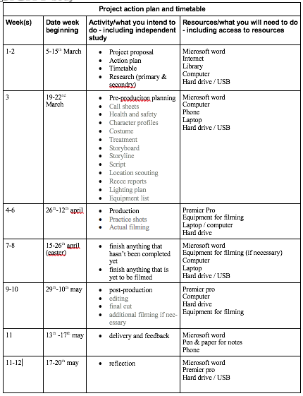
I managed to stay up-to-date with everything in my project. This was due to me completing work at home when I wasn’t in college. I admit I should’ve been in college more but unfortunately that wasn’t something I could control; despite this I was able to stay on track of everything and organise myself quite easily.
The only aspect of the plan I didn’t stick to was production week. I was only able to film after we came back from Easter due to both actors’ conflicting schedules. So, what should’ve been the beginning of post-production week was actually where I filmed the video.
Overall, I believed I stuck to the action plan as closely as possible, that’s why I believe the project went as smoothly as it did. I could’ve structured it so that I wasn’t packing so many tasks into one week, I did get overwhelmed at one point, but I managed to push through and complete the majority of work at home.
March 7th, 2019
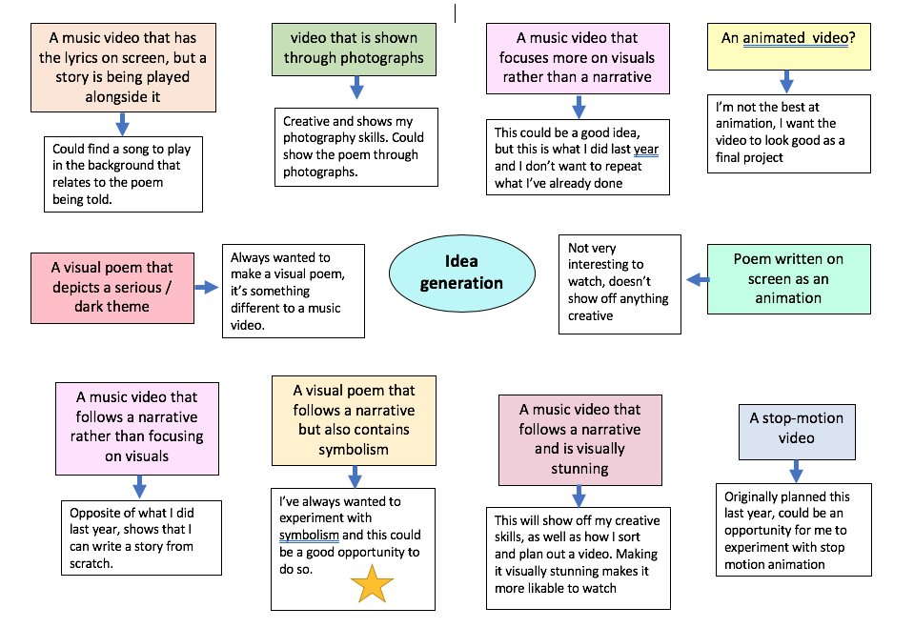
On this date, I made a spider diagram inspired document as an idea generation sheet. As I mentioned on my blog post, I knew I wanted to make a narrative driven music video, but I didn’t see the harm in exploring other video ideas as well.

Eventually I cycled through 10 different ideas that I thought could be used as a video for my final project. I decided to include some video ideas that weren’t solely focused on a visual poem. Beneath the ideas I explained why I liked or didn’t like the idea in the end.
I eventually chose the narrative driven visual poem. I thought it might be difficult to make a visual poem that doesn’t follow some sort of narrative. Plus, I find these videos more interesting to watch because you’re able to see the story of the poem played out rather than in your mind.
This didn’t take long to do as I already had a few ideas circling in my mind just after I wrote the proposal. All I had to do was compile them all into one space and explain why I decided not to pursue that idea. This allowed me to narrow the chosen ideas down as I went through the mind map and eventually settle on one idea.
If I could change anything about this process, I could have made a normal list rather than a mind map. The one I made is somewhat hard to navigate and I didn’t exactly highlight which idea I was going for, so I should have made that more clearly. I also could have taken my time to really think about each idea or develop them further to gather a better image in my mind of what that idea could look like. This task really helped me figure out what I wanted to do for the final project. Once I had found out what I wanted to do, I decided to do some more research.
March 8th, 2019
I decided to research symbolism in music videos on this day. The reasoning for this was because I consider music to be poetry with a melody. I also decided to do it this way because I’m not the best at analysing symbolic poems because they do confuse me, so I decided to use music videos for my main research. Music videos also have narratives and I thought that this would help me structure the video for my chosen poem. The music videos I looked at were:
- Kesha - Praying
- Naughty Boy ft. Sam Smith - La La La
- Mark Ronson ft. Miley Cyrus - Nothing breaks like a heart
- Madonna - Like a prayer
- Nirvana - Heart shaped box
The most interesting video to analyse was by Naughty Boy and Sam Smith. I felt as though it had a lot of symbolism and deeper meanings throughout the video that just made it enjoyable to analyse. All of the videos were fun to analyse anyway, I enjoy reading into music videos or any other form of film to find out what it means exactly.
This research helped me understand symbolism much easier and how directors and producers include symbolism that is hidden well. Either it’s shown quite clearly like the video for ‘Nothing breaks like a heart’ or its very subtle like ‘La La La’.
If I could go back to this phase, I probably should have looked at a poem or two and analysed the symbolism in them. After all, it’s a visual poem I was making - not a music video. However, I do stand by my point that music can be considered poetry, so I’m not concerned about wasting time on researching these videos.
March 11th, 2019
On this day, I was mainly focused on watching music videos with narratives. Just like the symbolism research, I went through the video and talked about what was happening as the song progressed. The songs I looked at were:
- Alt J - Breezeblocks
- Hozier - Take me to church
I decided to watch these videos because I have seen them before and knew that they both have interesting narratives. The Alt J video was my favourite to analyse because it’s played in reverse, so the story isn’t actually clear until the end of the video.
If I could do this task again, I would have definitely researched more music videos and poems too. Unfortunately, I was slightly behind schedule and did rush this part, I thought I could go back to it in the future to add more into it, but I didn’t find enough time to fit it in. I was too busy with other parts of the project to focus on this and it’s something I should have worked harder on.

Pre-Production
March 12th, 2019
By this time, I thought that I had done enough research to find a usable poem for my video. I had decided that I definitely wanted to make a visual poem, so this was the next step to take. I mentioned that I had already known about Havisham and Human Interest (by Carol Ann Duffy) due to studying them briefly in year 10. Even back then I was able to picture how I would re-create these poems visually, so I thought it would be a good idea to use these two poems as video ideas for this project. The third poem that I could picture making a video for was Joey (by Neil Hilborn). I found this poem around a year or two ago from a video I saw online of the writer performing it on stage. The writing is so clear to me and very easy to visualise in my mind and that’s why I included this poem in my chosen poem suggestions.
Like I mentioned in my blog post, Havisham would have been a great poem to visualise because I could have turned it into a very dark and twisted picture, but I had to think realistically about the video. I wouldn’t be able to buy enough props or make my own set for the video to make it look believable. If I had some sort of budget, I probably would have made a video for Havisham. I didn’t go with Joey either because I would have needed at least 4 or 5 actors to be in the video and I only know 3 people that would be willing to be in a video for me. By process of elimination, I decided to go with Human Interest because it only has 2 characters in the poem, and I knew 2 people willing to help me out so this was the perfect fit.
If I could have done anything differently, I could have analysed a poem or two more just to get more variety of choice. It isn’t an issue for that that I only suggested 3 poems to make a video for, but I could’ve looked around more and found a poem that was a bit longer than the one I chose. I also should’ve gone into more detail of why I didn’t choose the other two poems because looking at the blog post now, there’s not a lot of detail included. This is something I will have to work on in the future.
March 14th, 2019
I thought it would be a good idea to look through the poem again and analyse it more thoroughly. I went through each line or sentence of the poem and explained what was happening. This allowed me to better understand the poem and write down what I could show in the video for each line or sentence.
This job didn’t take me long to do as the poem is quite straight forward anyway. I wouldn’t change anything I did for this task because I believe that I have enough detail for each line of the poem. It also wasn’t so time-consuming, so I think this task went as smoothly as possible.
March 15th, 2019
Once I had analysed the poem in more detail, I went on to research the codes an conventions or a video. I decided to do this because in my last project I wasn’t the one who did this task, so I thought it would be a good idea to look over it myself and understand it better. Just with the previous research I’ve done, I focused on music videos again.
This was one of the most time-consuming documents for this project. I took my time with it because I wanted to really understand what each section was about and take mental notes of what I could do in my video.
First of all, I wrote a short description of what codes and conventions are. As soon as I started writing this, I began to understand it more clearly. I found that there are two different types of codes and conventions which re the technical side and the symbolic side. I also mentioned that codes and conventions are used to structure videos, without them videos wouldn’t be as good as they are. I then continued the blog post by adding some sub-categories for the codes and conventions such as:
- Performance videos - Videos that just include the artist performing the song.
- Narrative videos - Videos that include a story line
- Animated videos
- Surreal videos - Videos that would be ‘impossible’ in the real world
- Mixed videos - Videos that include two or more of these categories
- Parody videos - Videos that aren’t meant to be taken seriously
- Videos including a cameo
- Different editing techniques - Camera angles, shots, colour, effects etc.
For each of the sub-categories I included a music video that gave my description a bit more clarification. I had no trouble finding videos that fit into these categories because I’m familiar with a lot of music videos, so I knew which ones to include on the list.
I believe that this research was he most beneficial as I learned so much about the codes and conventions that I previously did. I wouldn’t think that animated videos or parody videos would be included in the list, but because of the research I carried out I now know.
This blog post took me a while to write because there was so much to cover in one space. If I could go back, I think I could have split the research into 2 or 3 separate blog posts because maybe then I would have a clearer mind when making the posts. Another thing I could have done differently was add a bit more information to each category. It’s such a hefty post (1429 words) and I believe at times I did tend to ramble. Next time I do a project similar to this I will remember to keep the blog posts as short as possible but also with enough information included to get my point across easier.
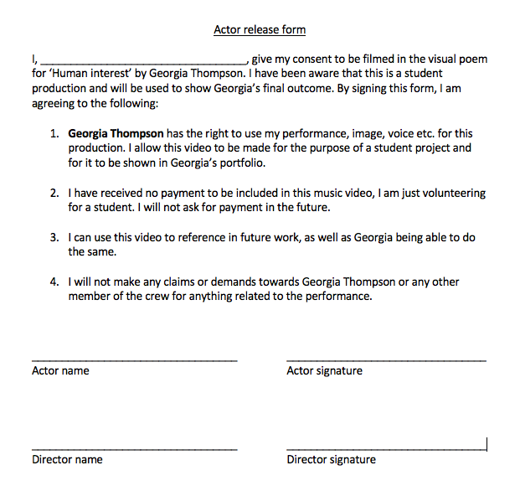
March 20th, 2019
I decided that the actor permission forms had to be finished by this time. I had two people in mind to help me in this project - Daisy and Ioan. Before I could do anything with them, I knew I had to make a consent form. As I explained in my blog post, this was made because it is (technically) a legal document stating that neither of them can sue me for not asking permission to use their image. Just before filming started, I asked Daisy and Ioan to sign the papers just so that I had proof for their permission.
This process didn’t take me long to do at all. In my last project, Alex gave me a note listing what I should include on the interview form and I managed to find it as I was preparing to type it out. The list of bullet-points helped me write the interview form without any disruptions or complications and I was happy with the final result.
If I could have done anything differently, I probably would have added a bit more information onto the actor release form. It’s not much of an issue for me as I did state everything clearly on those forms, but a part of me thinks a bit more information could have made them look more professional. I now know that this is essential part of film making, if I hadn’t done this then I could have gotten into legal trouble.
March 21st, 2019
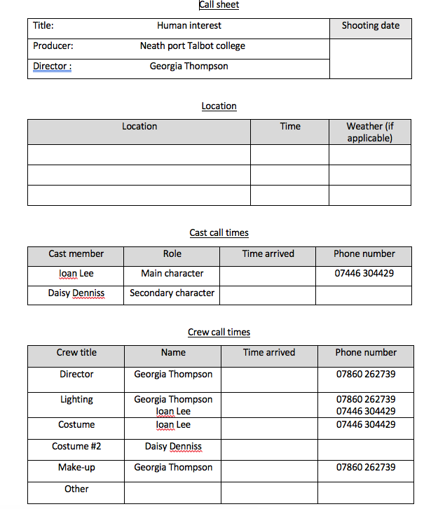
Today was the day that I made the call sheets for my video. Call sheets are documents that detail who was on set, what time they arrived and their contact details in case they don’t arrive on time or at all. I have made call sheets in every project during my time in college o I knew exactly what had to be included on this document.
I made sure to list the name of the production, as well as the producer and director of the video. Next to this I included a space where the date of filming could be filled in by whoever is managing the call sheet on that day.
Underneath that section is where the location, time and weather is listed. This section is essential because if anything goes wrong on the day of filming or something doesn’t turn out right in editing, we can look at this information and find a time and weather that reduces the chances of continuity in re-shoots.
Next, I added the cast’s name, role in the video, the time they arrive and phone number. Like I mentioned before, the phone number was just in case one of the cast members don’t arrive and if we need to find out why.
The final section of the call sheet is the job roles, names, time arrived and contact numbers of the crew. Again, this allows us to see who is allocated to what job role, what time they arrive on set and a contact number if they don’t arrive.
I kept my call sheet straight forward and spacious - a lot of examples I saw online were clustered and confusing to read, so I decided to keep mine simple enough but with a good amount of information included. If I could change anything, I would have added the time of filming next to the date just so that re-shooting would start at a similar time. I also would have added additional information about outside locations. For example, if I was shooting outside in a park or at the beach, it may be hard to find that exact spot again. If I was able to add information about that particular spot, then as we are re-shooting, I would be able to frame the shot close enough to the original shoot.
March 26th, 2019
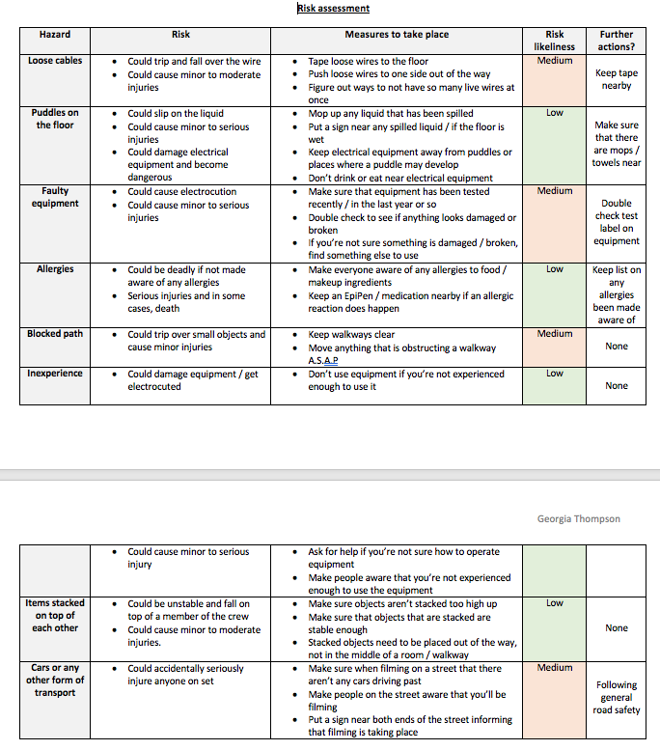
The risk assessment - I find - is the easier documents to make in any projects. I’ve never had any issues with it because I understand quite clearly what has to be done. Risk assessments are made to show that you’re aware of what could happen during or after shooting, and you’ve identified the risks and how to prevent them from happening.
The risk assessment I made has more than enough detail included in it to show that I understand different risks, how to prevent them, the likeliness of those risks happening and if there’s any further action needed.
On the likeliness of the risk happening, I colour coded each one with either green, orange or red. I believed that none of the risks were to be labelled as red which would mean it’s very likely to happen, so the only two colours I did use were green and orange. I’m confident that I labelled them correctly, since none of these accidents actually happened on set.
If I could re-do this section, I would most likely add a little more information on the potential accidents that could happen and how to prevent them. I feel as though I could have gone a bit more in depth for each risk, however I do think that there’s enough information on this table as it is.
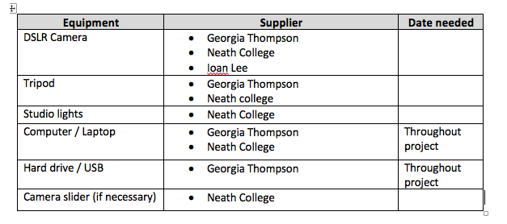
March 27th, 2019
On this day, I managed to complete the equipment list for my video. Equipment lists are used to keep track of what equipment you need, and also it reminds you to book equipment beforehand to ensure that it’s available on the day of filming. I listed everything I needed on the day of filming. I also took note of who was supplying the equipment. Luckily, most of the equipment I needed – I already had. This meant that I didn’t have to worry about if the store room at college didn’t have enough to give out on the day of filming. I made sure to leave some sections blank for me to figure out when I needed the equipment.
This process was fairly easy to complete, I wouldn’t change anything about this because I did everything according to plan and correctly, which made this document really helpful when I figured out my dates for filming.
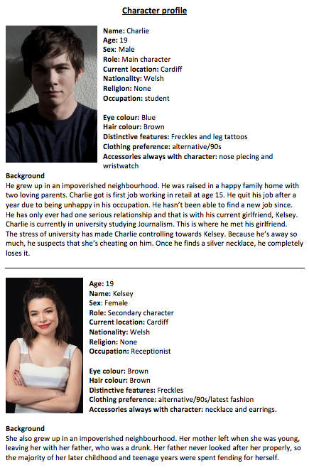
April 2nd, 2019
The character profile was one of the more detailed jobs to complete in this project. I really had to think about every detail of my characters for the video. I thought that it was a good idea to read through the poem over and over just to get a better image in my mind of how I wanted my actors to portray the characters.
I tried to include as much detail into the background section of the character profiles. I wasn’t too concerned about how I wanted the characters to look because I don’t know many people as it is, so if I tried to find someone exactly as the character description it would have taken up too much time.
I made sure to have enough detail in the background of the characters to give more of a backstory as to why they are the way they are today. I mentioned briefly about Charlie’s sanity being broken after suspecting Kelsey of cheating on him. This stems from the silver necklace he finds that was a gift to her from someone else. The poem doesn’t actually state where the necklace is from, so I thought it would be smart to have the idea of him being mistaken and murdering his girlfriend over no solid proof.
If I could change anything about this part of the project, I think I should have found actors first before writing the character profile. This way the physical description of the characters would match the description of the actors I found. This isn’t that much of an issue for me though, but I recognise that I could have done it this way around instead – just to make it more accurate.
April 3rd, 2019
Today I managed to complete two tasks and upload the process onto my WordPress blog. The health and safety document was kept pretty straightforward. Luckily my step father is a nurse, and since I was filming at home, I knew that if an accident did happen, he would be able to help us out.
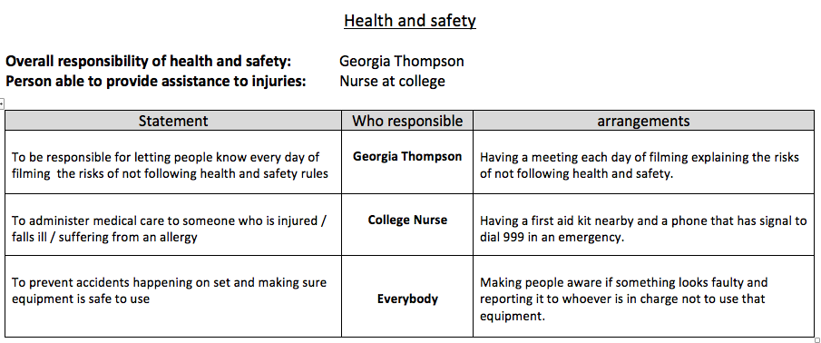

On the health and safety from, I stated who was responsible for overall health and safety and the arrangements that would need to take place. The purpose of this document was to keep everyone safe during filming and what to do in=f an accident did happen. Luckily nobody was hurt during filming because we were all responsible around equipment and objects – especially the knife in the video.
It was straight forward to make this document and I didn’t run into any difficulties making this. If I hadn’t made this document and someone did get hurt during filming, I could have gotten into serious trouble because I didn’t have proof that I understood health and safety on set. i could have added a bit more information on the arrangements but I do believe the document is a valid statement for understanding health and safety.
The second post I made was for the video treatment. I had been working on this over the weeks just to make sure that everything was kept up to date on the form, and that I had enough information on the form about the video I was going to make.

I made sure to include the background of each character to give some context on the document. Next, I explained what will happen in the video. I kept it short and simple just so that I wouldn’t overload the reader with too much information about the video itself. After this, I wrote a brief storyline of what happens in each part of the video. So, I mentioned the intro, the murder scene and the confession scene. This explains the majority of the video without giving too much away.
I believe the treatment could have been made slightly better. I could have added a bit more detail into what happens in the video and explained each part a bit more clearly. Nevertheless, it’s still a readable document and it’s easy to understand too, so it’s a successful document.
April 4th, 2019
The storyboard and mood boards were completed on this day. I enjoy making storyboards because it allows me to show everyone how I visualise the story in my mind. It’s a good indication of how I want to frame the shots, what I want the area to look like and how I want the actors to act.
I kept the storyboard straight forward, I included all the necessary information, which is the shot type, what happens in the scene, sounds that will be playing and who or what will be shown on screen. I made sure that the storyboard was easy to navigate by putting arrows next to each photo to follow the story.
The mood board as a bit harder to figure out. Like I said in my blog post, I’m not exactly sure how much or how little I need to include on this. Despite this I tried my best to show the theme of the video and what will happen during it. I also added some key words about the video to give more context and understanding.
If I were to do anything differently, I would have made sure that I completely understand how to make a mood board. I think my attempt Is a good attempt but looking back on it now I could have made it slightly better by adding more key words or including a wider variety of photographs. The storyboard, I believe, doesn’t have any issues at all. I stated clearly what I want to show on what scene, what shot type I would like, the camera angle and sounds to hear during the scene which is all you really need in a storyboard. However, I could have made it a bit longer and added more photographs for each section, but I still think that it clearly shows what I wanted to include in the video.
The next task I did on this day was finding actors to be in my video. Daisy and Ioan were the two people I knew that would be willing to help me out on my final project. daisy has helped me complete almost all of my video projects, so I was confident that she was able to help me out again. I wasn’t sure if loan was able to help me out because the times, I was planning on filming were when he had to revise for university, so I was worried that I wouldn’t be able to borrow him for the video. Luckily, they both agreed to be a part of the project which lifted a huge weight off of my shoulders.
However, if things hadn’t gone to plan then I have realised that I could have been left with one or no actors. I should have had a back-up plan just in case. If this did happen, I would have most likely asked drama students if they could help me out in the production. Yet again, that would have depended on their availability at the time. Ioan and Daisy worked extremely well together and I’m grateful that they managed to help me out in this final project.
Once I had found actors, I was able to book the college studio. Now that I knew I had people willing to be in the video, as well as what props and equipment I needed, I felt as though it was finally time to book the studio. I managed to book it 3 weeks in advance to ensure that I definitely was able to use the studio for the amount of time I had booked it for. I thought that Monday and Tuesday would give me enough time to film the confession scenes with Ioan and I was right.
Due to the fact that I was able to book the studio in enough weeks in advance, I had no problems during filming with anyone interrupting or claiming they had booked the studio, so in the future I will need to make sure that I book equipment and a studio at least a month or two in advance to guarantee no disruptions.
April 5th 2019
The lighting plan and production schedule were made on this day. I decided to draw out the lighting plan because my eyes started to get strained by using the computers so much, I needed to give them a break so I wrote it down on a piece of paper.
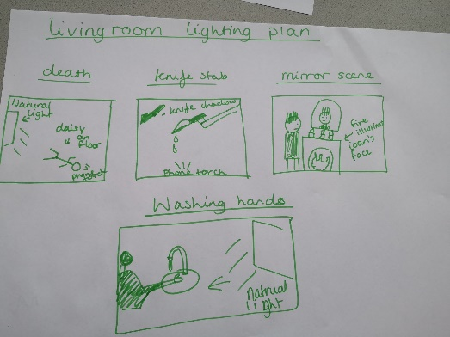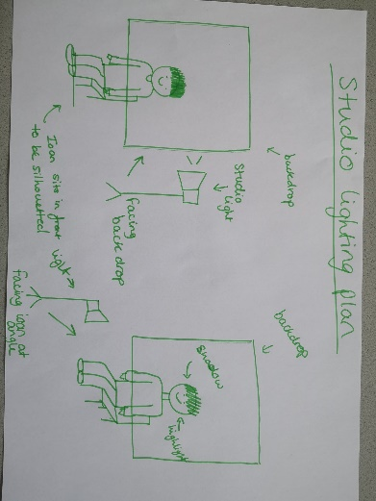
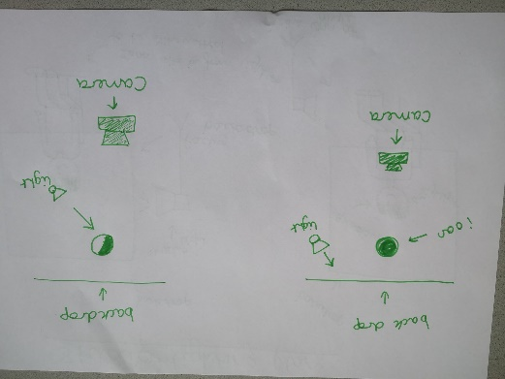
The lighting plan in my house mainly consisted of using the natural light from my living room window and a phone torch to help brighten up smaller details. In a real setting I wold have used studio lights, but due to having no budget and it being a student production I had to work with what I had.
The lighting plan for the studio all consisted of using the studio lights to illuminate the picture. I have used the studio lights several times back when I did photography last year, and I know how to get a good balance of highlights and shadows. I wanted to take some inspiration from when we studied film noir, so I had to angle the lights in a way that would cast harsh shadows across Ioan’s face, as well as creating silhouettes. I was planning on using the silhouette screen they have at college, but I decided not to do this as the studio lights weren’t focused enough to cast a solid shadow. I know this because when I did shadow puppetry for my Welsh Bacc assignment last year I had to use my phone torch.
I labelled everything clearly as well as doing overhead drawings of the set ups in the college studio. I didn’t want to over complicate the lighting plan so I just took note of where the studio lights would be, where loan would need to be situated and the placement of where the actors would need to be for the natural lighting to work.
If I could re-do this lighting plan, I would use a whole piece of paper for each plan. This way I wouldn’t have crammed everything into one small space – especially with the lighting plan for my house. At the time I thought it looked fine, but now looking at it I could have presented it better.
The next task to complete was the production schedule. Now that I had found actors, booked the studio and had a vague idea of where I was filming, I started planning out what to do during the production phase.
The original plan was to have my friend Claire to help me with practising in the studio, but she wasn’t available for that day anymore. However I did use a bit of time in the studio to figure out how much space I had and where I would place the lights, camera and in filming.
I listed who had to be on set on that day, where the filming would be taking place, the equipment I would be using on that day and the date of filming. All these points are necessary information because a few days before filming I looked at this and knew what I had to bring and where I was filming.
I believe that this document doesn’t have any faults, and therefore I wouldn’t change anything about it. It’s clear enough to understand, it isn’t overloaded with information and it actually helped remind me what I needed during filming.
April 9th 2019
I eventually completed the prop list by this date. I went through the poem as I made this list to figure out what props would be needed and when.
In the table I made, I thought it would be a good idea to mention the prop name, what character was using the prop, when the prop was needed and how the prop is used or shown. Every time I looked back on this list during filming it reminded me of who was using the prop and how. The props I didn’t end up using were the phone, clothing and calendar. I didn’t use these because during the practise shoots they just didn’t look right or I scrapped the idea entirely.
The prop list is more detailed than what I would have made in the past which shows that I can now think about certain tasks in more detail and what has to be included in each document. If I could change anything, I would have made sure if I was definitely going to use all the props so that I didn’t have to spend time thinking about and listing props that wouldn’t be used.
April 10th 2019
I managed to finally complete a shot list by this point. I was holding it off for a while because I had to make sure that I had planned out everything before I could think about the structure of filming the video.
With this shot list, I wanted to show that I have a better understanding of what makes a detailed shot list. I thought I should include more than just the shot number, shot type and description. I wanted to add more detail into the list because it shows that I’m able to pay attention to detail which is essential in the media industry. On the shot list, I included:
- Shot number
- Verse of the poem
- Shot type
- Exact line of the poem
- Action
I also decided to do the re-enactment scenes in a separate table to the confession scenes. I did this because I thought it would make it easier for me to find what I needed to film on the day of the studio shoot and vice versa. This actually helped me a lot more than if I had mixed the two together. I’m glad I did it this way because it made filming go so much smoother.
I believe that the shot list I made has enough detail included to let any reader understand what I intend to do on whatever part of the poem. If I could change anything, I would have added a few more extra shots. I came to find that the video itself was just under 2 minutes- if I added extra shots in between each verse or some sentences then it would have extended the length of the video.
April 11th 2019
I realised that the studio was empty on this day, so I quickly made a recce report before someone had to use the studio. I took a photo of the setup in the studio to include on the recce report to see it visually rather than just read about it. I made sure that the information on the report was accurate and detailed enough for me to look over and decide if it was the best place for me to film. Due to it being the only studio I know of that I didn’t have to pay to book, I had to go with this option anyway. I decided not to include photos of my house on the recce report for privacy, so the only shots in the video will be inside my house.
Both recce reports are accurate enough to be useable during filming and to keep in the production folder. If I could do anything differently, I would have tried to add a bit more detail and added more photos of inside the photography studio. This way it would have shown clearly the amount of space available for shooting and what the surroundings looked like from all angles.
Production
April 29th to 3rd 2019
This week I began filming the visual poem. Because I had planned everything out carefully and precisely, this was probably the most relaxed and easy going filming I’ve experienced compared to the other projects I made. The only issues I had during filming was the lighting as it was a cloudy day so not a lot of light was getting into the living room, but other than that everything went as planned almost perfectly.
As I was following the shot list, some shots didn’t look right or the framing was off, so I had to improvise on the spot of what I wanted the scene to look like. I haven’t got the biggest living room or bathroom, but I managed to use the space around me to give me enough space to film in. I was also worried about my dog getting in the way or appearing in the background of some shots, but she stayed on the sofa and watched as we filmed the project.
Daisy and Ioan worked very well together which is something that surprised me. I thought it was going to be awkward since Ion and Daisy haven’t really met before, but they really wanted to help me out in the project. Their relationship on screen is almost believable – considering Daisy isn’t an actor and Ioan tends to get shy in front of a camera.
The studio shot also went smoothly because I know how to use lighting in a way to make someone look eerie or mysterious. I set the camera to black and white to get an idea of the light and dark contrast, and I believe I managed to get this perfectly. One of the silhouette scenes does looks little rough, but because I couldn’t get Ioan back in to film, I couldn’t really do much about it.
The rest of the week I focused on filming quick shots here and there to add as an intro. I found this a little hard because my stepdad wouldn’t let me put fake blood on anything in case it got stained (it stained a few things) so I had to figure out a way to make regular objects and rooms look scary. I feel as though I managed to make these shots appear spooky or unsettling which is the effect I wanted to achieve.
If I could change anything about the filming process, I would have made sure that I could borrow Ioan and Daisy more just in case I had to re-shoot some scenes. I also would have filmed a lot more footage with and without the actors. This is because the video length is just under 2 minutes. I wasn’t aware that there was a minimum limit to the video until near the end of the project, and I didn’t have time to film anymore because I had to catch up on blog posts and finish other documents that were uncompleted. I would have most likely filmed cut away shots during Easter, and then filmed everything else with Ioan and Daisy. Despite this I believe that the final video is the best video I’ve created from my time at college.

Post-production
May 6th to 17th 2019
During this period, I was solely focused on editing the video and preparing it for the final edit. This process was fairly straight forward, I managed to sort out each video file into separate folders which made the importing task so much easier. I also separated all the audio recordings of Ioan into separate files, so importing those was straight forward.
Linking the image with the audio file wasn’t too hard to do as in the recordings loan paused between each sentence, so it was simple for me to cut the audio and divide it into sections. For each audio recording, I had to manipulate the audio to make it sound as though it was a phone call. This was the most time consuming job for the whole project. I initially tried to figure out how to do it myself for about an hour, but eventually found some videos on YouTube to help me out on this. Once I had figures out how to create the audio effect, I managed to create a sequence that followed the story of the poem.
I also added colour filters onto the video clips to enhance certain features. For example, the shots inside the studio were all done in black and white and to get the film noir effect I had to adjust the contrast and brightness of the image. I also made some shots appear blue-ish, I did this because back in photography, Ali mentioned that changing the “temperature” of the image makes it appear colder (more distant, uneasy) or warmer (inviting, pleasant).
The editing process took me around 2 weeks to complete and I am pleased with what I managed to do all alone. I thought it was going to be a struggle as I never thought of myself as a good editor, but I feel as though I managed to develop my editing skills by adjusting the colour balance and audio frequencies. If I could do anything differently, I would try to balance out the light and darkness in some shots – in the scene where Daisy and Ioan are arguing, the curtain behind them looks grainy. I would have tried harder to get rid of this effect.

Conclusion
In conclusion, I believe that this project had the least disruptions and faults compared to all the other video projects I have made throughout my time at college. I put all my time and effort into this project and it definitely paid off. I managed to pre-plan everything carefully to avoid any mistakes or issues during filming and editing, and in return it didn’t cause me as much stress as other projects have in the past. I am proud to say that I made this video alone. At the beginning of the project, I was doubting whether I would be able to pull it all off with the least amount of issues. I feel as though this is the best work I’ve made from my time at college. When I watch my video from last year, I realised that I could have done so much more with it. This year I wanted to make sure that I made something that I didn’t feel awkward showing to friends and family – I managed to do this.
Although there were some issues I came by, they still didn’t stop me from giving up on the project. I found a poem that I enjoyed reading, and I was able to visualise it which is something I thought I wouldn’t be able to do well. If I ever come to apply for university or any job in the media industry, I will show them this video and explain how proud I am of myself for making this video – considering I’ve gone through a lot of issues this year at college alone.
Overall, I am most pleased with how this project turned out. I admit there were some things I could have done differently for each step, but I am so happy with what I was able to make, and I’m looking forward to what I will be able to make in the future now that I have completed this course at college.

