Location | My house
Address | 18 alltygrug road, ystalyfera. Swansea, SA9 2AQ
Type of location | House
Why suitable | Dark interior for moody shots, lots of space. Plug sockets and access everywhere.
Location Recce report
Transport | Car / service bus / train
Physical access | Front and Side door
General info | Street outside so need to be mindful of filming outside.

Power sources | Yes – Power sockets on walls and extension cables
Toilets | Yes
Noise levels | Minimal
Space to film | Yes
Storage for equipment | Yes
Catering | Yes
Phone signal / WIFI | Yes
Lighting | Indoor and natural light
Access to whole area | Yes

Restrictions?
To be careful with surroundings and respect privacy.

Location | College photography studio  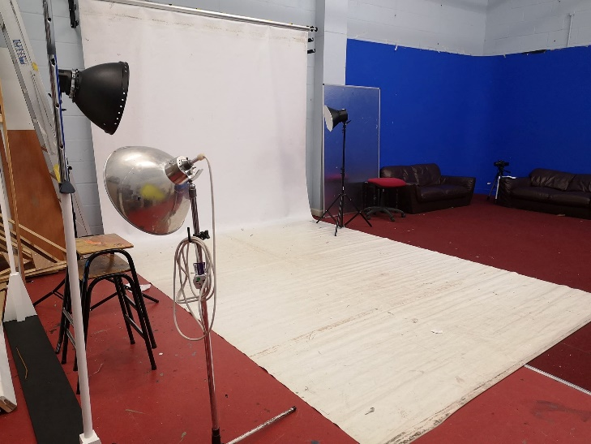
Address | Dwr-Y-Felin Rd, Neath SA10 7RF
Type of location | Studio
Why suitable | Dark interior for moody shots, lots of space. Plug sockets and access everywhere.
Location Recce report
Transport | Car / service bus / train
Physical access | Doors all around college block  Stair case and elevator leading up to studio  Double doors for disables access
General info | 3 regular studio lights and several overhanging coloured studio lights

Power sources | Yes – Power sockets on walls and extension cables
Toilets | Yes
Noise levels | Minimal
Space to film | Yes – but limited
Storage for equipment | No
Catering | Yes – café downstairs
Phone signal / WIFI | Yes
Lighting | Studio lights and stage lights
Access to whole area | Yes

Restrictions?
Make sure that

